Artificial Intelligence, Robotics and Future Technologies
This document was prepared as a Microsoft Word formatting exercise. Students should improve the formatting of the document and use advanced Word features. The text intentionally contains plain headings without proper styles. Students must apply Heading styles, add captions to all images and tables, and generate automatic lists and references.
Student tasks
Apply Heading 1, Heading 2, and Heading 3 styles where appropriate.
Format the document to improve readability.
Add captions to all images and tables.
Generate an automatic Table of Contents.
Generate a List of Figures.
Generate a List of Tables.
Insert page numbers.
Adjust spacing, alignment, and fonts.
Introduction to Artificial Intelligence
Artificial Intelligence, often called AI, is one of the fastest-growing areas of technology in the modern world. AI systems are designed to perform tasks that normally require human intelligence. These tasks include recognizing speech, understanding language, solving problems, and making decisions.
Many students interact with AI every day without even noticing it. Recommendation systems on YouTube, TikTok, Netflix, and Spotify use AI algorithms to predict what users might enjoy. Smartphones also use AI for facial recognition, voice assistants, and camera improvements.
The development of AI started many decades ago, but recent advances in computer hardware and data processing have allowed AI systems to become much more powerful. Today, companies invest billions of dollars into AI research because they believe it will transform industries and everyday life.
Machine Learning
Machine Learning is a branch of AI that allows computers to learn from data instead of being directly programmed. A machine learning model improves its performance by analyzing examples and finding patterns.
For example, a spam filter in email systems learns which messages are unwanted by studying thousands of emails. Over time, the system becomes better at recognizing spam automatically.
Machine learning is used in medicine, finance, transportation, gaming, and education. Self-driving cars use machine learning to identify roads, signs, and pedestrians. In medicine, machine learning helps doctors detect diseases more quickly and accurately.
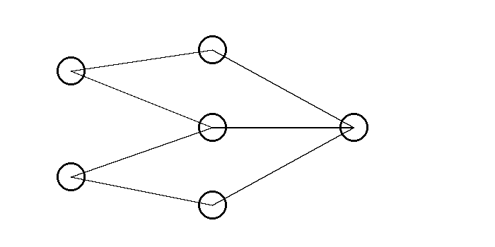
Caption: ........................................................
AI Technologies Comparison
Technology | Example | Main Purpose
Voice Recognition | Alexa | Understanding speech
Image Recognition | Face ID | Recognizing faces
Recommendation Systems | Netflix | Suggesting content
Autonomous Vehicles | Tesla | Self-driving transport
Caption: ........................................................
Robots in Everyday Life
Robots are machines that can perform tasks automatically or semi-automatically. Industrial robots are commonly used in factories where they assemble cars, move heavy objects, or perform dangerous tasks.
Household robots are also becoming more popular. Robotic vacuum cleaners can clean rooms without human assistance. Some robots can mow lawns or even help elderly people with daily activities.
In the future, robots may become common in schools, hospitals, restaurants, and public transportation systems. Engineers are working on humanoid robots that can communicate naturally with humans.
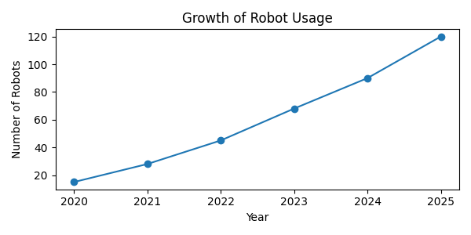
Caption: ........................................................
Advantages of AI and Robotics
AI and robotics can improve efficiency and productivity. Machines can work continuously without becoming tired, which allows companies to produce goods faster and more accurately.
In healthcare, AI systems can analyze medical scans and identify diseases earlier than humans in some situations. Robots can assist surgeons during complicated operations.
AI can also improve safety. Dangerous jobs such as mining, firefighting, or deep-sea exploration can be performed by robots instead of humans.
Challenges and Ethical Problems
Despite many advantages, AI also creates serious challenges. Some people worry that automation may replace many jobs in the future. Workers in transportation, manufacturing, and customer service may need to learn new skills.
Privacy is another important issue. AI systems often collect and analyze large amounts of personal data. Companies and governments must ensure that this data is protected.
There are also ethical concerns about autonomous weapons and decision-making systems. Society must decide how AI should be controlled and regulated.
Future Technologies
Scientists believe that future AI systems will become even more advanced. Researchers are developing technologies such as brain-computer interfaces, advanced robotics, and intelligent assistants.
Space exploration may also benefit from AI and robotics. Robots can explore dangerous environments on other planets where humans cannot easily survive.
Students who learn programming, engineering, and problem-solving skills today may have opportunities to work in exciting future industries.
Advantages and Disadvantages of Artificial Intelligence
Advantages | Disadvantages
Fast data processing | Possible job replacement
Automation of tasks | Privacy concerns
Improved healthcare | Dependence on technology
Better transportation systems | High implementation costs
Caption: ........................................................
Conclusion
Artificial Intelligence and robotics will continue to shape the future of humanity. Understanding these technologies is important for students because many future careers will require digital and technical skills. Ethical and social challenges must also be considered to ensure that technology benefits society.

Teacher's Notes
The document intentionally contains unformatted headings and missing captions. Students should use Microsoft Word tools to create a professional document layout. The final version should include an automatically generated Table of Contents, List of Figures, and List of Tables.

